SOAP Ui

[Swagger UI (mindtree-emp.azurewebsites.net)](https://mindtree-emp.azurewebsites.net/swagger-ui.html#/employee-controller)

1. Go through the above URL to get details about the APIs.

Adding post Request:

Adding Get Request:

Adding Put Request:

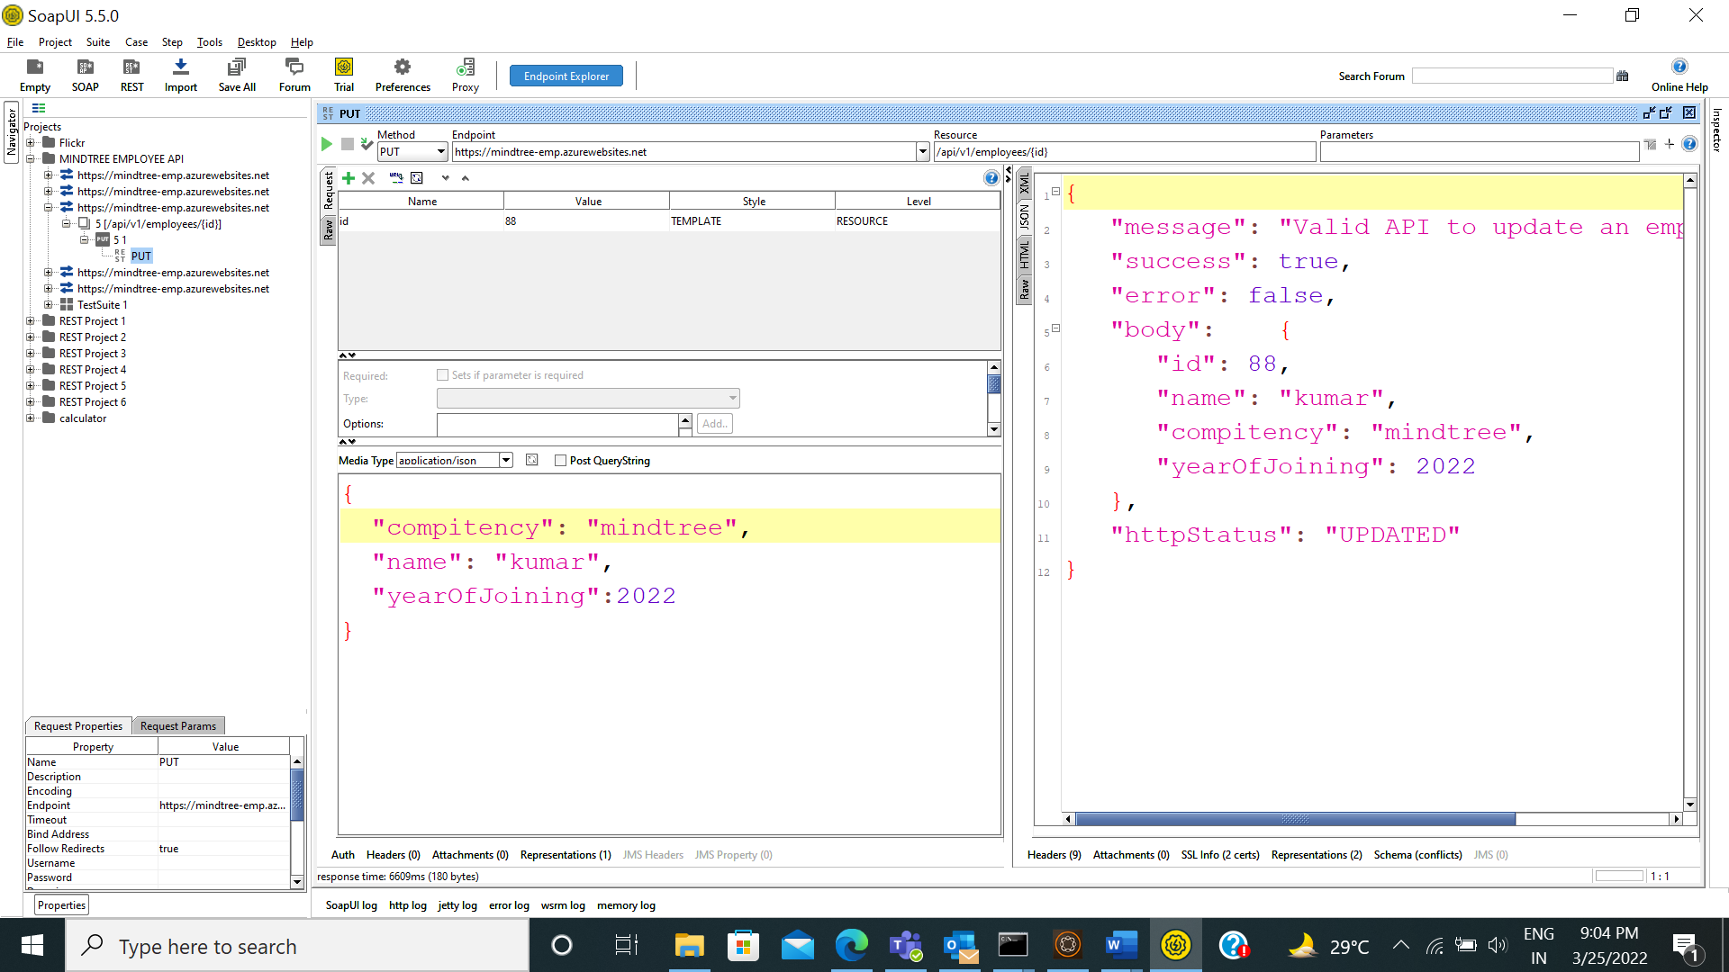

Adding Delete Request:

Adding TestSuite , Test case , Test Steps:

Groovy Script:

import jxl.*

import jxl.write.*

import groovy.json.JsonSlurper

//Excel Data For POS

Workbook work = Workbook.getWorkbook(new File("C://Users//M1080609//Desktop//EmployeeData.xls"));

Sheet data = work.getSheet(0)

String compitency = data.getCell(0,1).getContents()

String id = data.getCell(1,1).getContents()

String name = data.getCell(2,1).getContents()

String yearOfJoining = data.getCell(3,1).getContents()

//post request starts

testRunner.testCase.testSuite.setPropertyValue("compitency",compitency)

testRunner.testCase.testSuite.setPropertyValue("id",id)

testRunner.testCase.testSuite.setPropertyValue("name",name)

testRunner.testCase.testSuite.setPropertyValue("yearOfJoining",yearOfJoining)

def postrequest = testRunner.testCase.testSuite.testCases["TestCase 1"].testSteps["POST Request"]

log.info "one"

log.info postrequest

log.info"Running POST Request"

def rest=postrequest.run(testRunner,context)

def jresponse1 =postrequest.testRequest.response.responseContent

JsonSlurper slurper = new JsonSlurper()

def parsedJson = slurper.parseText(jresponse1)

if(parsedJson.httpStatus.equals("CREATED")){

log.info"POST Request got executed and details are added successfully"

assert true

}else{

log.info"POST Request got failed and unsuccessful"

assert false

}

//Get

testRunner.testCase.testSuite.setPropertyValue("id",id)

def getrequest = testRunner.testCase.testSuite.testCases["TestCase 1"].testSteps["GET Request"]

log.info"Running GET Request"

def rest1=getrequest.run(testRunner,context)

def jresponse2 =getrequest.testRequest.response.responseContent

def parsedresponse1 = slurper.parseText(jresponse2)

log.info(jresponse2)

if(parsedresponse1.httpStatus.equals("ACCEPTED")){

log.info"GET Request has run successfully"

assert true

}

if(parsedresponse1.body.name.equals(name) && parsedresponse1.body.compitency.equals(compitency) && parsedresponse1.body.yearOfJoining.equals(yearOfJoining.toInteger())){

log.info"Details of the employee are present"

assert true

}else{

log.info"Employee Details are not present"

assert false

}

//Excel Data For PUT

compitancy = data.getCell(0,2).getContents()

id = data.getCell(1,2).getContents()

name = data.getCell(2,2).getContents()

yearOfJoining = data.getCell(3,2).getContents()

//Put

testRunner.testCase.testSuite.setPropertyValue("compitency",compitency)

testRunner.testCase.testSuite.setPropertyValue("id",id)

testRunner.testCase.testSuite.setPropertyValue("name",name)

testRunner.testCase.testSuite.setPropertyValue("yearOfJoining",yearOfJoining)

log.info"Running PUT Request Updating the values"

def getIdTestStep2 = testRunner.testCase.testSuite.testCases["TestCase 1"].testSteps["PUT Request"]

def rest2=getIdTestStep2.run(testRunner,context)

def jresponse3 =getIdTestStep2.testRequest.response.responseContent

def parsedresponse2 = slurper.parseText(jresponse3)

if(parsedresponse2.httpStatus.equals("UPDATED")){

log.info"Employee details are updated successfuly and put request got successfull"

assert true

}else{

log.info"Employee details not updated successfuly and put request got failed"

assert false

}

//Get

testRunner.testCase.testSuite.setPropertyValue("id",id)

def getIdTestStep3 = testRunner.testCase.testSuite.testCases["TestCase 1"].testSteps["GET Request"]

def rest3=getIdTestStep3.run(testRunner,context)

def jresponse4 =getIdTestStep3.testRequest.response.responseContent

def parsedresponse3 = slurper.parseText(jresponse4)

if(parsedresponse3.httpStatus.equals("ACCEPTED")){

log.info"GET Request was successfully"

assert true

}

if(parsedresponse3.body.name.equals(name) && parsedresponse3.body.compitency.equals(compitency) && parsedresponse3.body.yearOfJoining.equals(yearOfJoining.toInteger())){

log.info"Employee details was Updated"

assert true

}else{

log.info"Employee details was not Updated"

assert false

}

//Delete

testRunner.testCase.testSuite.setPropertyValue("id",id)

def getIdTestStep4 = testRunner.testCase.testSuite.testCases["TestCase 1"].testSteps["DELETE Request"]

log.info"Running DELETE Request"

def rest4=getIdTestStep4.run(testRunner,context)

def jresponse5 =getIdTestStep4.testRequest.response.responseContent

def parsedresponse4 = slurper.parseText(jresponse5)

if(parsedresponse4.httpStatus.equals("DELETED")){

log.info"Empoyee Details has been deleted and request passed"

assert true

}else{

log.info"Empoyee Details not deleted and unsuccessful"

assert false

}

work.close()

Execution:

